Computer Science Project

Table of Contents

Table of Contents 2

Analysis 3
The Problem 3
My clients 3
Research 4
Existing Solutions 4
Existing Solutions Conclusion 5
Questionnaire 6
Questionnaire Results 7
Questionnaire Conclusion 8
Requirements and Limitations 8
Requirements 8
Limitations 8
Success Criteria 8

Design 8
User Interface Design 8
Algorithms 8

Analysis

The Problem
In today’s digital world, users are managing an ever-increasing number of passwords for digital accounts. Proven guidelines suggest creating long passwords that are unique, contain special characters and are as random as possible.
For the average user, it is very challenging to create and manage passwords that are secure while still being easy to remember. Password guidelines are proven to work well; Long passwords and special characters make brute forcing passwords non-viable, and real-randomness mitigates the human-nature to form patterns yet non-technical users would rather risk all their digital accounts for a more convenient login experience. Many users do not understand alternative means of managing passwords, while others choose the ease-of-use of remembering one password over security. Passwords are not inherently insecure, security is only as strong as its weakest link which in the case of passwords, the weakest link is the end-user.
Users can drastically improve their online security with a password manager. A password manager is a piece of software (or in rare cases, a piece of hardware) that manages a user’s passwords securely. A password manager stores users’ passwords and encrypts them with one single master password and often some other form of authentication in addition. Password managers are not a new concept and have existed for a while however many users still choose not to utilise one because they can cause friction while in use.
I would like to design a password manager that is extremely easy to use and doesn’t get in the user’s way. Users would need to sign up with an email address and a secure master password. The password manager would store a lot of data; this type of data would be best suited for storage on a computer system. This is because there is a lot of data that needs to be protected and backed up. With a password manager, the data needs to be backed up multiple times to ensure no customers passwords are ever lost or corrupted.
To protect the passwords being managed by the password manager, cryptographic functions such as encryption and hashing will be required. These functions are extremely difficult and almost impossible to do by hand even in an unreasonable timeframe. Hence, using a computer system which can compute the required functions in the matter of seconds is a necessity. Therefore, my password manager is best suited to a computational solution.

My clients
Anybody who uses the internet and manages any form of digital account is my target audience. Chances are, anyone who uses the internet will also have many digital accounts they need to manage. My password manager will be as simple as possible while offering all the required functionality. I want my password manager to be as frictionless as possible; I want the experience of adding and retrieving passwords to be no less convenient than just entering one password for every website. Users will benefit from the use of any password manager, however adding more options will help aid adoption hence why I want to create my password manager.
For accessibility features, I plan to create a high-contrast mode so people with partial sight can see the product better. I also plan to annotate my password manager so make it easy for screen readers to read the content successfully.

Research

Existing Solutions
There are quite a few password managers that the user can pick from. The ones I have chosen to look at are Lastpass and BItwarden and Keepass. All three of these password managers offer very similar services, although notably Lastpass is the only proprietary password manager out of this lot.
Lastpass is a cloud-based password manager that is popular. Lastpass allows you to store passwords but also other sensitive information like payment cards, addresses and even secure notes. Lastpass works on any platform either through a dedicated application or via a browser with the web-based application. Lastpass is free to use but it does offers paid plans.

Lastpass Pros
- Storing digital records like insurance cards.
- Sharing passwords is easy and secure, no need to email the password.
- Monitors for data breaches and alerts the user if their personal information is at risk.

Lastpass Cons
- Free tier only allows one type of device.
- Lastpass has had security breaches in the past.
Bitwarden is another cloud-based password manager. Bitwarden is nowhere near as popular as Lastpass. Bitwarden, is open source meaning that anyone can view its source code. Bitwarden allows you to store passwords and payment cards. Bitwarden also allows you to securely store and share files. Bitwarden works on any platform. Bitwarden has native apps for Windows, MacOS, Linux, Android and iOS. Alongside these native apps, Bitwarden also offers its web application which works on any browser. Bitwarden is free to use, and it does offer paid plans. Bitwarden also allows for self-hosting which means any individual can run a Bitwarden instance instead of using the officially hosted option.

Bitwarden Pros
- Unlimited Passwords and Unlimited Devices even in the free tier.
- Native apps for all platforms.
- Zero knowledge end-to-end encryption meaning that nobody, but the end user knows their stored information.
- Great enterprise support that allows for easy sharing of passwords throughout an organisation and single sign on support.
- Open source which means that thousands of people are looking over its source code to look for vulnerabilities.
- Can be self-hosted for organisations or for people who want to control their data.
- Offline support so the client doesn’t need to be online.

Bitwarden Cons
- Official, paid plans are more expensive that competitors.
Keepass is a local password manager. By local I mean that Keepass uses a locally stored database for managing passwords. Keepass is an open-source standard that many clients use to interact with a Keepass database. Keepass allows you to store passwords but not much more, it’s a password manager first and foremost. The official Keepass client has support for Windows, MacOS and Linux, however, there are many clients for other platforms such as Android and iOS. Keepass doesn’t do any form of synchronisation between clients which means it’s up to the user to manage the Keepass database between their devices. Keepass is free, the first-party clients are free and almost all third-party clients are free.

Keepass Pros
- Local database means that the end user is in control of their data.
- Open-source standard with many people constantly checking for exploits.
- Many third-party clients so a user can find one they like instead of being stuck with only the first-party client.

Keepass Cons
- Local database means the user is responsible for managing the database between clients.
- Can’t be used to store much more than passwords.

Existing Solutions Conclusion
From my research into existing solutions, I have concluded that I should create a cloud-based password manager that at the very minimum stores passwords and secure notes. I will cache the results from the API locally to allow for offline access. My password manager will be open source with a well-documented API to ensure that anyone can create replacement clients and servers. Like Bitwarden, I will be enacting a zero-knowledge end-to-end encryption system to ensure that only the user has access to their data. I plan to be completely transparent in how my password manager will function.

Questionnaire
I decided to ask a few people around my college about how they use and manage passwords. Here is the questionnaire I designed and asked people to answer:
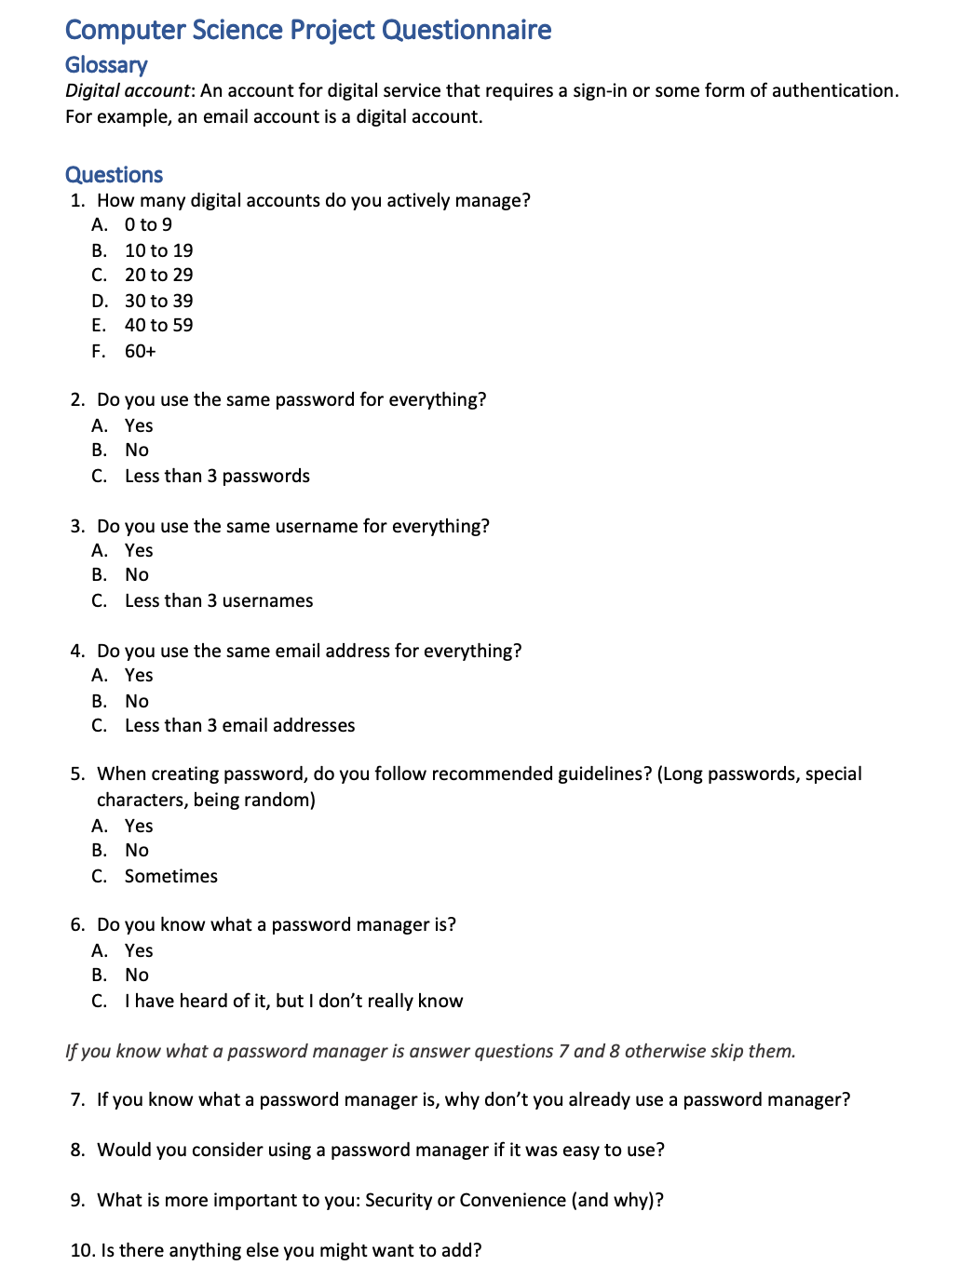
A large portion of the people I asked to fill out this questionnaire responded. I got a wide range of answers from a wide range of people. For multiple choice questions I have worked out the percentage for each answer. For the long-answer questions I have summarized them into a paragraph.

Questionnaire Results
Question 1: How many digital accounts do you actively manage?
0 to 9 | 11%
10 to 19 | 47%
20 to 29 | 20%
30 to 39 | 18%
40 to 59 | 4%
60+ | 0%
Question 2: Do you use the same password for everything?
Yes | 47%
No | 20%
Less than 3 passwords | 33%

Question 3: Do you use the same username for everything?
Yes | 53%
No | 25%
Less than 3 usernames | 22%

Question 4: Do you use the same email address for everything?
Yes | 67%
No | 10%
Less than 3 email addresses | 23%

Question 5: When creating a password, do you follow recommended guidelines? (Long passwords, special characters, being random).
Yes | 37%
No | 39%
Sometimes | 24%

Question 6: Do you know what a password manager is?
Yes | 67%
No | 10%
I have heard of it, but I don’t really know | 23%

Question 7: If you know what a password manager is, why don’t you already use a password manager?
I don’t use a password manager because I don’t know who I can trust with my important information, so I choose not to use one and instead opt to manage my own information. I don’t mind the added interference while using a password manager.
Question 8: Would you consider using a password manager if it was easy to use?
I would use a password manager if it was easy to use, given that my private information was being held securely and safely.
Question 9: What is more important to you: Security or Convenience (and why)?
A balance would be nice; I don’t want the most secure storage of my private details if it’s inconvenient to access. The same is true in reverse.

Questionnaire Conclusion
From this questionnaire I have learnt a lot about how users manage their digital accounts. Majority of users do not use a password manager, even though majority of users know what a password manager is. Many users use the same few emails, passwords and usernames for their digital accounts. From the people who know what a password manager is, the general response is that security and convenience should be balanced and that many users actively choose not to use a password manager out of security concerns. From this newfound understanding, I know that users need a password manager that is transparent in design so that users know exactly how their private information is being handled, my password manager should also be both secure and convenient to use.

Requirements and Limitations

Requirements
From my research, I have a few requirements for my final application. Firstly, data will be stored in the cloud so it can be accessed on multiple devices. I will need some form of versioning to ensure that there is no data lost while managing versions and possible collisions from multiple devices.
Secondly, I require that my application to allow users to quickly and painlessly create secure user accounts and I will require my application to allow the secure creation and storage of passwords. In which the server has no knowledge of the transaction.
Thirdly, while still being secure, must be convenient. For example, if a slightly weaker form of encryption is much faster, I will use it because from my research I found people want a balance of security and convenience with many more wanting a convenient experience.
Lastly, I require that my password manger uses end-to-end encryption so the server has zero knowledge and cannot under any circumstance access your data.

Limitations
Due to the time and cost limitations, not everything is possible. Firstly, I will not be able to get my password manager security audited so I will not know entirely if my resulting application has any vulnerabilities.
Secondly, my password manager will only handle passwords, due to time constrains its unrealistic to expect additional features that are not required by a password manager, for example, I will not be including secure notes like many of the competition do.
Thirdly, other password managers offer some form of breach detection where they notify the user if their password has been found somewhere online. I will not be able to do this.
Lastly, while I plan to implement WebAuthn I cannot test different forms of WebAuthn due to me not having access to a wide range of devices. In theory the implementation of WebAuthn works everywhere but I cannot test it.
Success Criteria
New users must be able to register with an email address and password.
- The email must be unique (in my database) and valid.
- The email must be verified before the account is active. This will be done by sending the user a verification email.
- The password must be entered twice for confirmation.
- The password must be validated to ensure its strong enough, it must have:
  - At least 12 characters
  - At least 2 special characters
  - At least 2 number
  - At least 2 lowercase
  - At least 2 uppercase
- All data that should be end-to-end encrypted and the server should have zero-knowledge regarding the transaction.
- The user will be given a recovery code, they will be highly encouraged to save it somewhere safe so they can recover their account in the future.
Existing users must be able to sign in with their email address and password.
- After every unsuccessful login attempt, an email is sent to the account owner informing them of failed attempted logins.
- After every successful login attempt, an email is sent to the account owner informing them of a successful login attempt.
- If the user attempting to login doesn’t have a verified email, then block login.
Existing users must be encouraged to enable two-factor authentication (2FA).
- There must be a selection of 2FA like:
  - Email verification
  - Time-based One Time Password (TOTP)
  - WebAuthn
- It must be easy enough so that anyone who isn’t technically savvy can enable a form of 2FA in under 5 minutes.
Existing users can recover their account if they have forgotten their password using their recovery code.
- If the recovery code is correct, send a verification email. If the verification email is successful, allow the user to change the password.
- If the recovery code is incorrect, the account owner will get notified via email.

Existing users can create/view password entries.
- All data that should be end-to-end encrypted and the server should have zero-knowledge regarding the transaction.
- Allow for additional fields that will be stored alongside the entry. This data will also be encrypted.

Design

Algorithms
Password-Based Key Derivation Function 2 (PBKDF2): This is a the most used algorithm in my application. As the name suggests it derives keys based upon passwords. PBKDF2 is recommended key derivation function by NIST, the National Institute of Standards and Technology. In my application I use PBKDF2 with SHA512 to derive strong keys. PBKDF2 requires 3 parameters. Those 3 parameters are the number of iterations, a salt and lastly the password to derive the key from. The number of iterations is the number of rounds the function will do, in simple terms, the higher the iteration count the longer it takes for a bad actor to crack a password/key. The second parameter, a salt, is a public, usually random byte sequence that is used for additional entropy which helps create an even more secure key (The more entropy in, the more entropy out).
SHA512 Hashing Algorithm:

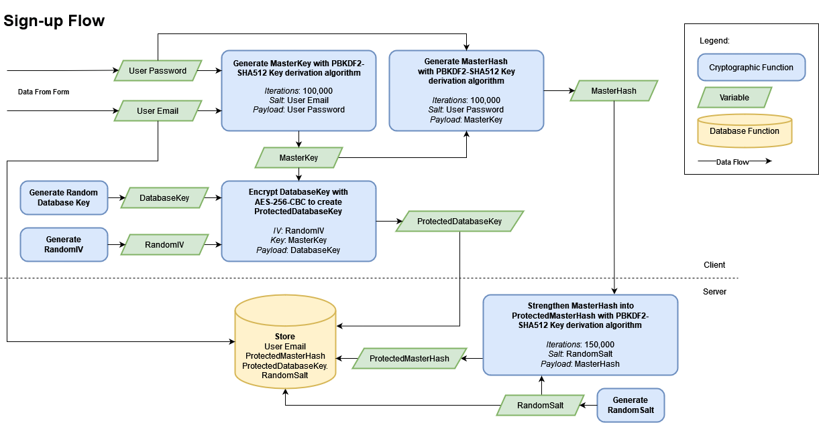
Modelling
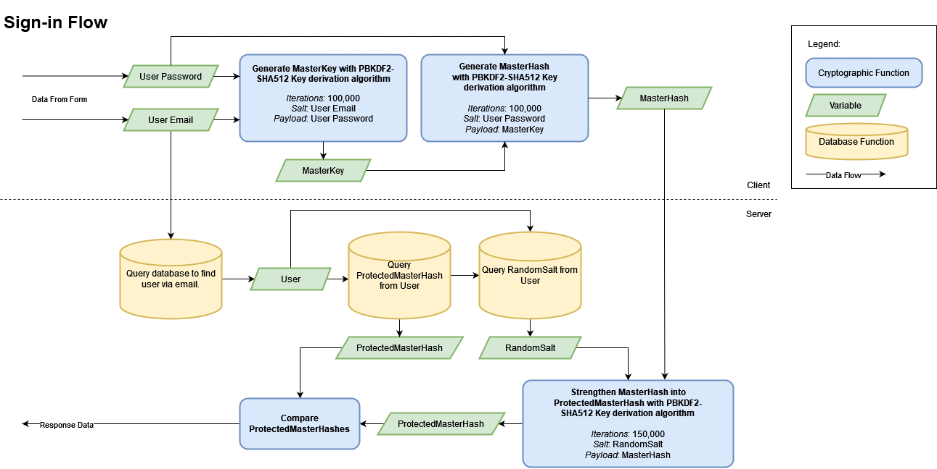

API Docs

{
"error": {
"code": "string",
"message": "string"
}
}

Test
test

